CPSC 131 Homework 7

Deadline: Wednesday, March 27 (MoWe sections), Thursday, March 28 (TuTh sections)
Turn in your submission as hard copy in class. Do not upload on TITANium.

#1 Drawing Trees

Given the following five nodes A, B, C, D and E, draw two different trees that contain only these five nodes.

#2 Describing a Tree
Given the tree:
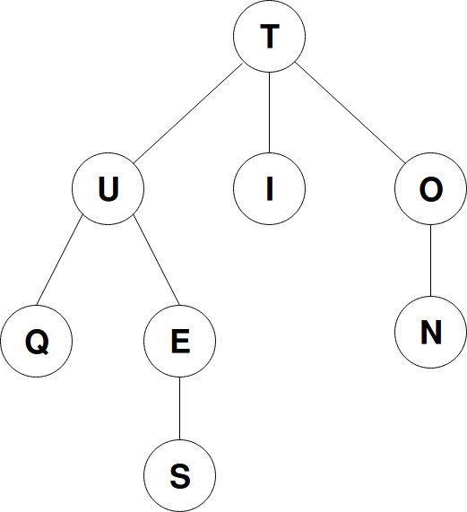

a) List the root of this tree:

b) List the internal nodes of this tree:

c) List the leaf nodes of this tree:

d) List the descendants of node U: (A descendant of U is any node other than U that belongs to the subtree rooted at U.)

e) List the ancestors of node U:

f) List the siblings of U: (A sibling of U is any other node that has the same parent as node U.)

g) Compute the depth of each node:

Node | Q | U | E | S | T | I | O | N
Depth

h) Compute the height of each subtree rooted at the given node: (Consider the height of a leaf node to be 0.)

Node | Q | U | E | S | T | I | O | N
Height

i) Write down the height of the tree:

#3 Identical Binary Trees
Given two binary trees B1 and B2, complete the function below that checks whether B1 and B2 hold the same integer values and have the same topology. Writing a recursive solution is highly encouraged.
The data structure to store a binary tree is given below:

struct TNode{
int value;
TNode *left, *right;
};

bool areIdentical (TNode *B1, TNode *B2)
// returns true if B1 and B2 hold the same value and have the same subtrees rooted at them
// to be completed

